Sunday School Teachers’ Scripture and Feast Day Weekly Memo
Sunday, January 21, 2018

From Today’s Readings

John 6:15-21 In this account of Jesus’ miracle of walking on the water, He assures His terrified disciples: “It is I; don’t be afraid.”(v.20). The original Greek is a more powerful construction, namely, “I AM,” echoing God’s very same self-identification to Moses at the burning bush. Discussion: Where in your life do you need to remember that Jesus is with you and there is nothing to fear?

2 Tim 2:15-26 Timothy describes the life of righteousness and love for all ministers in God’s service. To counter false teachings, he suggests instructing people gently so that their hearts might open to God’s truth. Discussion: Have you ever been involved in a “stupid argument” that led to even more quarreling (23-24)?

Is 61:10-62:9 Isaiah describes a covenant in which Israel will serve as priests mediating between God and others and in which they are clothed in “garments of salvation” and “robes of righteousness.”(v.10). These images are echoed in the Armenian rites of baptism and ordination as well as in the priest’s vesting prayers before the Divine Liturgy. Discussion: In naming His people priests, what is God asking them to do? What does a priest do? (Brings others to God in a variety of ways: witnessing to his faith, living a joyful, righteous life; celebrating the Divine Liturgy; baptizing and performing other sacraments; teaching; governing; serving, etc.)

Thursday, January 18, St. Antony the Hermit
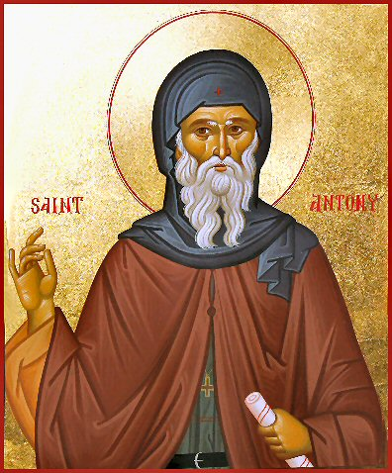
St. Antony (251-356 A.D.) was one of the most beloved and well-known of the “desert fathers and mothers” who in the 3rd century chose to live in prayerful solitude or in small communities in the desert wilderness in the Middle East and, primarily, Egypt. Antony was a pioneer in this lifestyle, leaving behind a privileged life, entering the wilderness near his home village of Koma in Egypt and beginning a life of ceaseless prayer and fasting that lasted almost two decades. By the time St. Antony had died in the mid- 4th century, thousands of faithful had been drawn to living in the desert following his example. St. Athanasius, another revered saint of the Armenian Church, wrote in his famous life of St. Antony that so many had followed him "the desert had become a city.” This astounding movement was the early foundation of Christian monasticism. The sayings of the desert fathers and mothers are widely available. One of the many attributed to St. Antony: 'I saw the snares that the enemy spreads out over the world and I said groaning, "What can get through such snares?" Then I heard a voice saying to me, "Humility.”’

Department of Christian Education
Diocese of the Armenian Church (Eastern)
elisea@armeniandiocese.org

