Sunday School Teachers’ Scripture and Feast Day Weekly Memo
Sunday, May 27, 2018

From Today’s Readings

1 Kings 18:29-46 Elijah’s prayer to God brings rain after a long drought, whereas the prayers of Baal’s prophets prove futile. This ‘contest’ is spectacular: 850 pagan prophets against the one prophet Elijah of the one God Yahweh. Elijah builds an altar with twelve stones upon which he places a sacrificial bull that is drenched repeatedly with water. This miraculously precipitates first God’s fire and eventually God’s healing rain. Discussion: What kinds of “showdowns” take place in your life, i.e. where is the one true God competing with the false gods in your life? What would it take for you to be convinced that God is more powerful than anything else?

2 Kings 2:1-15 As the prophet Elijah and his protégé Elisha travel from Gilgal to Bethany and then to Jericho, the prophets in each place remind Elisha that God would soon be taking his master from him; Elijah himself continues to remind his disciple of this. At the Jordan, Elijah rolls up his cloak and taps the river which parts for them to cross safely. He asks Elisha what he might wish from him, to which the young man replies: a “double portion of your spirit.” When Elijah is taken up to heaven in a fiery chariot led by flaming horses, he drops his cloak to the ground. Elisha picks it up, taps the river with it, and the water parts for him. The prophets realize that God’s spirit had descended now upon Elijah’s pupil. Discussion: At every step of his journey (vv 2, 4, 6), Elijah wants Elisha to stay behind, but Elisha stubbornly continues to accompany his master. What does this reveal about each man’s relationship with the other? Have you ever had the mantle of leadership passed on to you? What quality of your mentor would you have wished for?

James 5:16-20 In these concluding verses of James’ epistle, he advises his listeners to confess to and pray for each other, as the “prayer of a righteous person is powerful and effective.” He cites Elijah as a man whose prayers were indeed effective. He also notes how important it is to keep others from sin. Discussion: Have you ever confessed a wrongdoing to a fellow Christian? How did it help? In what ways does confession before receiving Holy Communion heal our souls?

Luke 4: 25-30 Jesus is at worship in a synagogue in his hometown of Nazareth when he teaches from the book of Isaiah about the “year of favor from the Lord,” a year which He proclaims to now have been fulfilled. At the congregation’s amazement, Jesus famously declares that no prophet is accepted in his hometown. He cites the examples of the prophets Elijah and Elisha whose healings were more readily accepted by non-Jews. So angered by this, the congregation drives Him out of town and to the edge of a cliff to throw Him down. But Jesus manages to leave them peacefully. Discussion: Perhaps we have more in common with this congregation of two thousand years ago than we think. Reflect prayerfully: Is there anything about what Jesus teaches that makes you so uncomfortable you would prefer to drive Him out of your life?

Today is the Remembrance of the Prophet Elijah

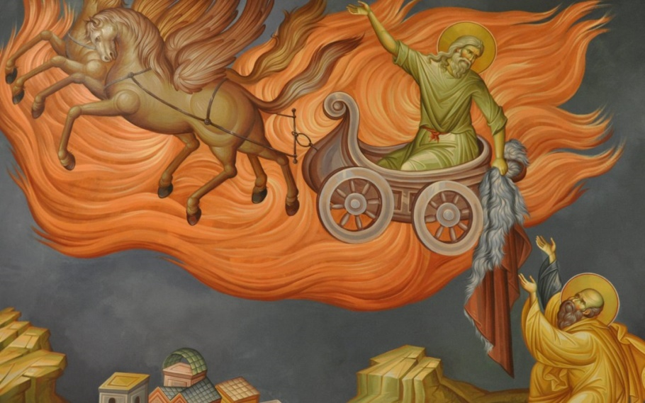
Elijah is an important Old Testament prophet for the Armenian Church, as well as Christian, Jewish, and Muslim traditions in general. Prophesying in the 9th century at the time of King Ahab and the infamous Queen Jezebel, he is a miracle worker and healer. But his greatest and most impactful quality was to declare and witness to the one true God, prevailing repeatedly and dramatically against false prophets and gods. At Jesus’ transfiguration, he stands as the symbol of the prophetic tradition next to Moses, symbol of the Law. For a detailed presentation of Elijah in the Armenian Church, see www.armenianchurch.us, “Saints and Feasts: Welcome the Stranger.”

Department of Christian Education
Diocese of the Armenian Church (Eastern)
elisea@armeniandiocese.org

