Scripture and Feast Day Notes
Sunday, August 12, 2018
From Today’s Readings
Isaiah 7: 10-16 In His ongoing communication with Ahaz, King of Judah (under attack from Syria and northern Israel), God suggests that he now ask Him for a sign regarding his fate. Ahaz refuses, thinking this would blasphemously test God. Exasperated, Isaiah shares that very sign: that a young woman will bear a child, that He would be called Immanuel (God with us) and that even before He grew to maturity, those attacking Judah would have ceased to exist. Discussion: Verse 14 is an unmistakable and significant prophecy for all humankind: the announcement of God’s unfolding plan of salvation through the appearance in human history of Jesus, God the Son. When facing a challenging crisis, how have you experienced Jesus as “God with us?”
Gal 3:29-4:7 In these verses, beautifully linked by the word “heir” in the first and last lines of the textual unit, St. Paul declares that now that we belong to Christ, we are His rightful heirs. As children, we were once no better than the slaves on any estate, tethered to the world’s ways. But “when the time had fully come, God sent His Son, born of a woman, born under the law…” (4:4) that we might receive the “full rights of sons.” Discussion: Read 4:6, a renowned verse on the veritable invasion of our hearts that God carries out. “Abba” is an intimate term for “Father” meaning we have been granted the unthinkable privilege of looking upon the Creator of the Universe as our “dad.” How was being an heir under the Law (4:1-3) like being an heir who is still a minor? How affectionate is your relationship with God?
Luke 1: 26-38 The angel Gabriel visits Mary with the news of her impending role as mother of Jesus (Asdvadzadzin, lit. “bearer” of God). In one of the most famous encounters in the Gospels, depicted in countless works of art and literature, Mary responds humbly but immediately to God’s call to a miraculous service. This has made many consider Mary to be the first of the apostles, the first to be “called and sent out” on God’s behalf. Discussion: Verse 37 is one of the most quoted New Testament verses “For nothing is impossible with God.” In what area of your life right now do you need to believe this is so? What keeps you from believing it?

Today is the Feast of the Assumption of Mary, the Mother of God
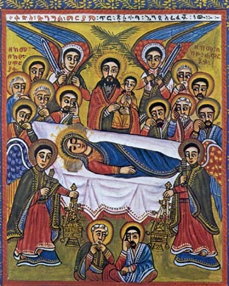
The oldest of feasts associated with St. Mary,
Assumption is celebrated on the Sunday nearest August 15 and commemorates the taking up into heaven (“assumption”) of the Holy Mother at her death. Tradition relates that Mary lived another 15 years after our Lord’s crucifixion. St. Bartholomew, the only apostle absent from Jerusalem when St. Mary died, asked to visit her tomb upon his return a short while after she was buried. When the tomb was unsealed, her body was gone and angels were heard singing for three days and three nights. The blessing of grapes is associated with this feast day. Grapes are the “first fruit” of the harvest, a reference to Jesus Himself and to St. Mary as the first apostle and witness to the new covenant. Grapes are also made into the wine of Communion.

Department of Christian Education/Diocese of the Armenian Church of America (Eastern) elisea@armeniandiocese.org.

