Khachkars, Coins, and Unusual Sources
Following the Feast of the Exaltation of the Holy Cross this past Sunday, the Armenian Church now enters into a season that focuses on the Cross: this week, we alternate between celebrations of the Cross and of the Church; in the weeks to come we celebrate the Feast of the Discovery of the Holy Cross and an uniquely Armenian celebration of the Cross, the Holy Cross of Varak. Another beautifully Armenian celebration of the Cross is the carved cross-stone, the khachkar, a devotional art form that has flourished in Armenia for centuries. As Der Garabed Kochakian wrote last week for VEMKAR, the khachkar, that Armenian artistic expression of devotion to Christ and the Cross, “became a mark of Armenian Christian identity.” They also, as he notes, “often carried inscriptions explaining why they were created.” This makes khachkars, in addition to objects of devotion and beautiful, expressive pieces of art, important historical sources.

Khachkars and Inscriptions
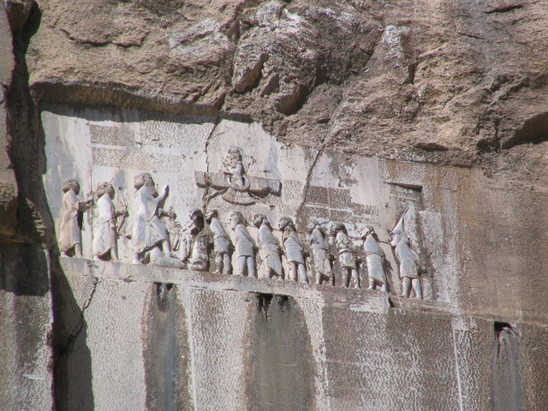
Though the first thing that usually comes to mind when we think of “sources” for history or other kinds of research are books—or perhaps archives with other types of documents—historians and other scholars make use of all sorts of important sources. Inscriptions on buildings or sculptures are one common and crucial kind of historical evidence. In fact, one of the earliest mentions of “Armenians” is the Behistun Inscription, a cuneiform text on a stela (a large upright vertical stone) extolling the achievements of Darius the Great of Persia. Much early history is known because of similar inscriptions.
One of the first scholars to make extensive use of inscriptions—also often called “epigraphic evidence”—for Armenian history is the beloved churchman and polymath Catholicos Karekin Hovsepian. In
Behistun Inscription
Creative Commons,
Aryobarzan at English Wikipedia
a recent conference at the St. Nersess Armenian Seminary, experts described Catholicos Hovsepian’s contributions. Much of his comprehensive history of Armenian princely houses, Khaghbakyank‘ kam Pṛoshyankʿ Hayotsʿ patmutʿyan mēj, is based on inscriptions that he himself visited and collected. Khachkars, in addition to inscriptions on churches themselves, are a major source of historically-relevant inscriptions. In this season of the Cross, these sources can help us appreciate the profound connection between the Cross as the divine symbol of salvation history and the inscriptions on ornately carved khachkars as bearers of historical knowledge.

Recommended Source | Summary
Armenian Art | A beautiful coffee table book with detailed discussions of different Armenian art forms (including khachkars) with accompanying pictures.
Khatchkar | Hrair Hawk Khatcherian’s striking photographs of Armenian khachkars.
Toward Light and Life: Reflections of Catholicos Karekin Hovsepian | A selection of writings by Catholicos Karekin Hovsepian which accompanied the recent conference at St. Nersess.
Khaghbakyank‘ kam Pṛoshyankʿ Hayotsʿ patmutʿyan mēj : patmagitakan usumnasirutʿyun | The three-volume history of the Khaghbakyan and Proshyan pricely houses by Catholicos Karekin Hovespian. In Armenian, an excellent example of the use of inscriptions for historical work.

Coins
Another unusual and beautiful historical source that can tell researchers quite a lot are coins. The study of coins and related items like medals—known as numismatics—is not only the purview of people interested in money itself. Coinage, with pictures of important people, dates, and values, also offers contextual clues about society and life at the time a coin was issued. The Zohrab Information Center has several beautiful books on Armenian coins. We even have, in addition to books about coins, a small collection of ancient and medieval coins. In addition to the books listed below, check out the Zohrab Information Center’s Instagram account zohrabcenter, for today’s post about a Roman coin in our collection!

Recommended Source | Summary
Coinage of the Artaxiads of Armenia | By Paul Bedoukian, a selection of coins with accompanying pictures from the early Armenian dynasty.
Coinage of Cilician Armenia | By the same author, focusing on the coins from the medieval Armenian kingdom of Cilicia.
Armenian Coins and Medals | An exhibition catalogue from the coins in the collection of Paul Bedoukian.

