Scripture and Feast Day Notes
Sunday, November 4, 2018

From Today’s Readings
Luke 8:17-21 Jesus tells His disciples to listen attentively to His words, as this will lead to deeper understanding; indifference and hardness of heart obscures even what one already understands. The visit of His family gives Jesus the opportunity to emphasize an important Gospel theme: The fundamental relationship with Him is not through blood ties (or belonging to the right church family), but rather through hearing and acting upon the word of God. Discuss/reflect: What are some ways you can be a better listener to His Word?
Ephesians 1:1-14 God’s saving plan began before creation itself, when He chose us in Christ (v 4) to be holy and blameless and destined to be His children. Those who belong to God’s family and have heard the “word of truth “and believed (v.13) are blessed with the Holy Spirit. Discuss/reflect: In vv 3-9, Paul clarifies the spiritual blessings God gave us in Christ (v.3): God created us to be His children, to be holy, to be forgiven and to know Him thanks to His grace. What blessings do you thank God for?
Isaiah 22:15-24 Isaiah warns Shebna, a court official in Jerusalem, that his self-importance and love of luxury will be humbled by God. Discuss/reflect: God criticizes the palace steward for honoring himself with a chiseled gravestone (v 16). Turn to Micah 6:8 for Godly guidelines for leaders: “And what does the Lord require of you? To act justly and to love mercy and to walk humbly with your God.” By these standards, how do you rate national and world leaders today?

Saturday, November 3, was the Feast of All Saints

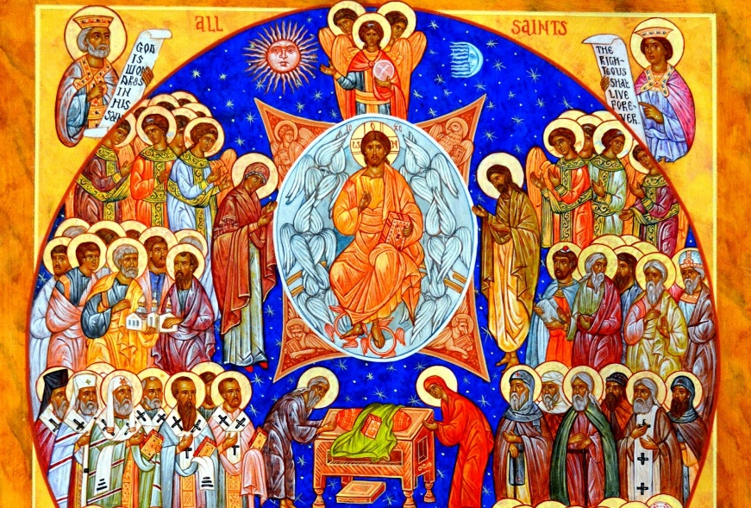
The saints acknowledged by the Church with special days on the calendar are not the only people who have dedicated their lives to God. There are many who remain unknown and nameless and yet lived a holy life just as devoted to Jesus Christ as the saints whom we know and remember. Through prayerful discernment, the Church recognizes some saints by name, but also proclaims that others may be resting in Christ and praying for us; these are remembered on the Feast of All Saints. We are indeed surrounded by a great cloud of witnesses (Hebrews 12:1) who cheer us on to live a holy and saintly life, to run the race of perseverance, as we fix our eyes on Jesus. Together the saints, the old and the new, the known and the unknown, have run that race and have persevered. They have shaped and built the Church, and modeled what it looks like to be Christian. As Christians, we are called to be more than just inspired by the saints, but to emulate their very lives and actions.
Department of Christian Education
Diocese of the Armenian Church of America (Eastern)
elisea@armeniandiocese.org

