Scripture and Feast Day Notes
Sunday, December 2, 2018

From Today’s Readings
Luke 13:1-9 Jesus refers to two disasters, one in which Pilate had a group of Galileans killed as they were making sacrifices, and another, a construction accident. He asserts that those who died were no more sinful than anyone else (countering a belief that suffering was often visited upon those who deserved it). But he urges all to repent and live a good life. Discuss/reflect: The parable of a fig tree not yet bearing fruit (vv 6-9) suggests that there might be some time to straighten ourselves out, but not much! The best time to repent and live godly lives is now. If you had a year like the fig tree to turn your life around, what would you do?
1 Thessalonians 4:1-11 Here St. Paul exhorts his readers/listeners to live in a way that will “please God,” urging believers to treat their bodies as holy, thereby honoring themselves and others. God called us to holiness and to love and respect others. Paul instructs believers to live quiet lives and be productively busy, relying on their work to sustain them. Discuss/reflect: Paul asks us to love “more and more” (v. 10b). How would that translate to your life? To your relationships?
Isaiah 36:22-37:11 Assyria continues to demand Jerusalem’s surrender, having earlier alluded to the inability of other gods to stop him from conquering other lands. Both King Hezekiah and Isaiah demonstrate their trust in the one true and beloved God over the Assyrian threat. Discuss/reflect: What threats do you think challenge your faith today? Do you trust in God to help you meet these challenges? If not, why not?

Saturday, December 1, was The Feast Day of Sts. Thaddeus and Bartholomew
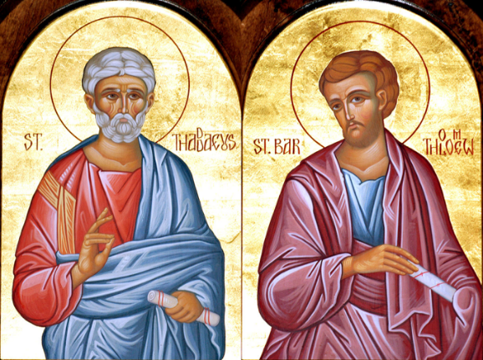
On the day of Pentecost, all the apostles were miraculously able to speak different languages; the apostles Thaddeus and Bartholomew were gifted with the knowledge of Armenian so that they might travel to Armenia and preach the good news of Jesus Christ, many decades before St. Gregory the Enlightener. That is why they are called Armenia’s “First Enlighteners.” St. Thaddeus converted many there to the Christian faith (c.35-43), including the king’s daughter, Princess Santookht.An enraged King Sanadrook had her executed along with her teacher and mentor St. Thaddeus for the treasonous act of following Christ. About this time St. Bartholomew arrived in Armenia, continuing to preach and heal (c. 43-65); he converted the King’s sister Voloohy. Again, Sanadrook’s anger resulted in executions, this time his sister and the apostle. The tomb of Thaddeus is near Makou and that of Bartholomew in Aghpag, both in historic Armenia.
Department of Christian Education/Diocese of the Armenian Church (Eastern)
elisea@armeniandiocese.org

