Scripture and Feast Day Notes
Sunday, November 11, 2018

From Today’s Readings
Luke 8:49-56 The synagogue official Jairus had begged Jesus to heal his ailing daughter. Immediately after, Jesus healed a woman who also reached out to Him in profound faith. Now Jesus hears the news that the official’s daughter has died. He tells Jairus not to be afraid, but only believe, and she would be made well. And indeed, Jesus brings her back to life. Discussion: Jesus had his closest disciples Peter, James and John witness this miracle. They alone were also present at His Transfiguration and in His agonizing moments in the Garden of Gethsemane. Which friend(s) would you let into your toughest and your most life-changing moments? Why? (Keep in mind that nobody’s perfect: Jesus’ three closest fell asleep in the Garden and Peter betrayed Jesus three times after His arrest.)
Ephesians 5:15-33 St. Paul has declared that our new identity as children of light calls us to live a different way. (5:8) He compares the love between husband and wife with Christ and the Church. (Ephesians 5:22-33 is read during the Armenian marriage ceremony.) Discussion: St. Paul advises that we give thanks to God “always and in everything” (verse 20). When do you find it difficult to feel grateful? Use moments of despair, bitterness, or anger to pause and list specific things to be grateful for. It’s not only a spiritual but a psychological truth: gratitude completely pushes out fear and anxiety!
Isaiah 24:1-12 Isaiah describes the devastation of the earth. The passage reads like a ritual mourning for the land and, unlike other similar prophecies in Isaiah, has not been linked with any historical catastrophe. Discussion: According to verses 5-6, what is the reason for the earth’s ruin? (People have disobeyed the sacred laws and broken the covenant.) How might we today be hurting ourselves or the earth by ignoring God’s laws and covenant?

Saturday, November 10: Holy Archangels Gabriel and Michael

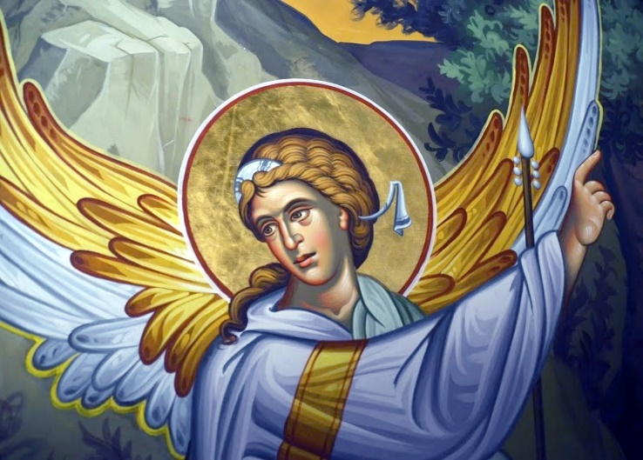
Spiritual beings created by God, angels are gifted with intelligence and free will. They are by nature invisible but can manifest themselves, if God so wills, in a physical form. The word ‘angel,’ (Armenian hreshdag) means ‘messenger.’ The Archangel Gabriel announced the birth of John the Baptist to his father Zechariah, and the birth of Christ to Mary, the Mother of God. The Archangel Michael, cited in the books of Daniel and Revelation, leads God’s armies against evil, guarding the Church. The Armenian Church, like all Orthodox churches, believes in the existence of guardian angels. “See that you despise not one of these little ones,” Christ said, “for I say to you that their angels in heaven always see the face of my Father in heaven.”(Matthew 18:10) Angels sing and celebrate in perpetual glorification of God. Through Christ we are granted full heavenly citizenship with the angels and share the privilege of praising God with them, singing in their presence during Badarak. Discuss/reflect: When an angel revealed God’s plan for them, both Mary and Zechariah thought that what God was asking might be hard (Luke1: 18, 34) What might God be asking of you? Department of Christian Education
Diocese of the Armenian Church (Eastern)/ elisea@armeniandiocese.org

