Scripture and Feast Day Notes
Sunday, April 28, 2019

From Today’s Readings
John 1:1-17 These renowned and eloquent verses testify to the presence of God the Son from the very creation of the world (vv 2-5); Jesus Christ was the ultimate revelation of God’s presence, glory, and enduring love. John the Baptist was called to be a witness so that “all people might believe.”(v.7) Discuss/reflect: Make a list of the attributes of Jesus (the Word) as described in vv 1-5 and 10-17. Give thanks for all that the Lord makes possible!
Acts 5:34-6:7 Two important events are recounted here. In the first, the teacher of the law Gamaliel exhorts the apostles’ antagonists to let them continue Jesus’ work, since if their purpose is godly they will prevail over any force against them anyway. The second is the first “ordination” as men are called and consecrated to assist the apostles in caring for the poor. St. Stephen was foremost among them and is considered the first ‘deacon’ of the Church. Discuss/reflect: Threatened by the Sanhedrin high priests, Peter and the apostles had to (v 29) “obey God rather than people.” Has there ever been a time you have faced such a choice? Can you imagine such moments in the future?
James 3:1-12 The apostle James explains the great harm that speech (the tongue) can cause and the importance of talking in godly ways. Discuss/reflect: To what three things does James compare the tongue? (a bit, a rudder, a spark) How do these images help us understand what our words can do? Have you ever had the experience of regretting harsh, unkind language? What were the circumstances?
Today is New Sunday
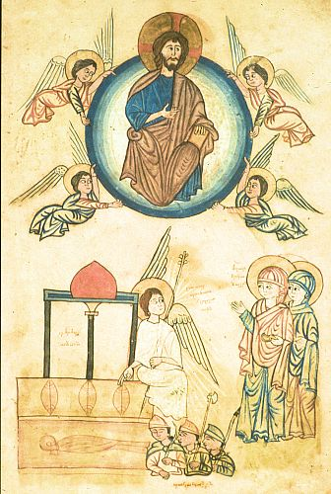
New Sunday (Nor Giragi) is the first Sunday after Easter. It commemorates the resurrection of Christ and is therefore referred to as the “Second Easter” (Grgnazadig). The Sabbath was originally on Saturday, the end of the seven-day week and the day on which God rested after creation. But in the early church, Christians began to celebrate the day of the Resurrection as the Sabbath so that the new day for resting in God became Sunday. In theological terms, it became the 1st day and the 8th day of the week, signifying both beginning and fulfillment. The Gospel reading for New Sunday (John 1:1-17) summarizes the mission of Jesus Christ, God the Son, who existed from the beginning as God and participated in the creation. He became human to bring us into the light, to guide us out of our spiritual darkness. New Sunday also bears a message for the growth of the Church.

Department of Christian Education
Diocese of the Armenian Church (Eastern)
elisea@armeniandiocese.org

