Scripture and Feast Day Notes
Sunday, April 7, 2019
From Today’s Readings
Matthew 22:34-23:39 In these verses, Jesus defines the two greatest commandments (22: 36-40) in which all the law and prophecies of the Old Testament can be summarized. In 23, there is an extended warning (the “seven woes”) against the vanities and false pieties of the Pharisees. The reading concludes with Jesus’ poignant lament for Jerusalem in which (22:37) – in one of the rare moments when a female metaphor for God is used – He yearns to protect its people as a “mother bird gathers her young under her wings.” Discuss/reflect: In chapter 23, where does Jesus capture your attention? What practices touch close to home in your life?
Colossians 2:8-3:17 In a beautiful accompaniment to today’s Gospel, St. Paul urges us to depend on Christ rather than human tradition or worldly principles. Through baptism we have died with Him and are raised with Him into faith and a new way of living. That virtuous, good life is eloquently described in 3:12-17. Discuss/reflect: In 3:9-10 we read that in Christ “you have taken off your old self with its practices and have put on the new self, which is being renewed in knowledge in the image of its Creator.” Comparing the “old” ways described in 3:5-8 with the “new” outlined in 3:12-17, how would you rate yourself? Where do you need more of His help?
Isaiah 66:1-24 Isaiah conveys God’s promise of both restoration and judgment. His children will thrive and be comforted in a new Jerusalem; those who persist in false worship and disobedience, however, will be harshly judged. Again (as in the Gospel passage above), we are offered a beautiful female image in verse 13: “As a mother comforts her child, so I will comfort you.” Discuss/reflect: Do you think sometimes we focus more on the form of worship rather than what it’s all about? If so, explain.

Today is the Annunciation to Mary and the Sunday of the Advent
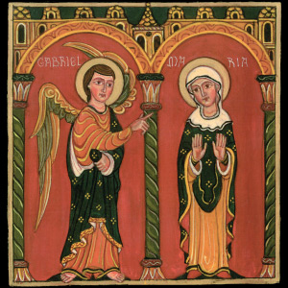
On the infrequent occasion when the Feast of the Annunciation falls on a Sunday during Lent, the joy of that feast takes precedence over Lenten disciplines. The altar curtain is opened and Holy Communion distributed during Badarak. The visit of the angel Gabriel to St. Mary appears in Luke 1: 26-38; here we learn how the very young and deeply faithful Mary humbly accepts her role in God’s redemptive plan for all humankind.
The Lenten lesson remains dedicated to the Second Coming of Christ when He will come again -- this time not as a gentle and lowly Savior, but as a righteous judge in the glory of His Father and with a retinue of angels. Department of Christian Education
Diocese of the Armenian Church (Eastern)
elisea@armeniandiocese.org

