Scripture and Feast Day Notes
Sunday, June 30, 2019

From Today’s Readings

Matthew12: 1-8 When the Pharisees chastise Jesus for allowing His disciples to pick grain on the Sabbath, He cites many instances from their own history (King David) and tradition (practices of priests at the Jerusalem temple) to counter their accusations. Ultimately, though, it is now Jesus who is Lord of the Sabbath. Discuss/reflect: How do you keep the Sabbath holy?

Romans 6: 12-23 St. Paul exhorts his listeners to reject sin as their master, since they now live under grace rather than the Law. God has freed us from enslavement to sin; obedience leads to righteousnessness. “The wages of sin are death;” but holiness leads to eternal life with Christ Jesus. Discuss/reflect: If St. Paul were here today, what sins would he say enslave our society?

Isaiah 1: 1-15 God despairs of a rebellious people who continue to turn from His ways. Since their hearts are not open to God, their worship and prayers are meaningless. “Your incense is detestable to me…I cannot bear your assemblies!”(v.13) Discuss/reflect: Worship of God needs to spring from genuine faith to have meaning. How would you rate your worship?

Tuesday, July 2, honors Sts. Constantine the Emperor and his mother Helen
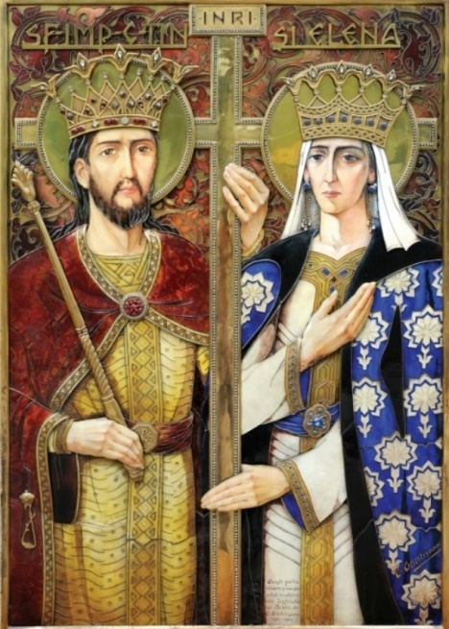
From the moment Constantine succeeded his father Constantius as Emperor of the Western Roman provinces in 306 (and eventually becoming the sole ruler of the Roman Empire in 324), he changed the course of Christian history. He was the first Roman Emperor to convert to the Christian faith, most probably under the influence of his mother Helena, a convert herself, and a woman known for her love and service to the poor. He is credited for the Edict of Milan in 313 which mandated tolerance for Christianity in the Empire. He convened the first Ecumenical Council (Nicaea) in 325 to address church controversies. His early construction of a church over the site of Jesus’ tomb led to the later establishment of the Church of the Holy Sepulcher in Jerusalem over which the Armenian Church shares authority. And in his quest for the true cross of Christ, he dispatched his revered mother Helen to Jerusalem, where, in 326, she discovered three crosses at an excavation site. In order to determine which was the Cross of Christ, one source reports that St. Macarius, the Patriarch of Jerusalem, alternately touched a corpse to each; the deceased came to life at the one deemed the True Cross. This event is an important feast in the Armenian Church -- Discovery of the Holy Cross (Kiud Khach) -- celebrated in October. Discuss/reflect: St. Helen’s faith clearly had a huge impact on her son, who was in a position to make a larger difference in the world than most. How do you influence loved ones with your Christian faith? Department of Christian Education Diocese of the Armenian Church (Eastern)
elisea@armeniandiocese.org

