Scripture and Feast Day Notes
Sunday, August 4, 2019
From Today’s Readings
Matthew 18:10-14 Jesus had just cited children and their open-hearted, unfettered faith as the answer to the disciples’ question: “who will be the greatest in the Kingdom of Heaven?” With the story of the 100 sheep, He confirms that the Father cares for them all fiercely and equally; He will leave the 99 and look for the one lost sheep, celebrating joyfully when it is found. Discuss/reflect: What do you need to do to recapture a child’s sense of wonder and faith in God’s power?
1 Corinthians 1:25-30 St. Paul reminds the faithful that it was not because of their superior qualities that they were called to faith, rather God calls people out of their foolishness, their unimportance, and their weakness, to a strength and widsom that can only be found in Christ. Discuss/reflect: What images come to mind when you think of “successful” people? Are these at odds with the kinds of success God can empower us to achieve?
Isaiah 3:16-4:1 In God’s judgment on Judah and Jerusalem, Isaiah has already described the breakdown of social order. He now focuses on the women, whose finery and beauty – representing a culture of luxury and pride – he describes in detail. All will be removed and defiled as punishment. Discuss/reflect: Do you see this “haughty” (v.16), self-centered attitude encouraged by today’s consumer culture? How?

Monday, August 5, is the Feast of St. Cyprian the Bishop
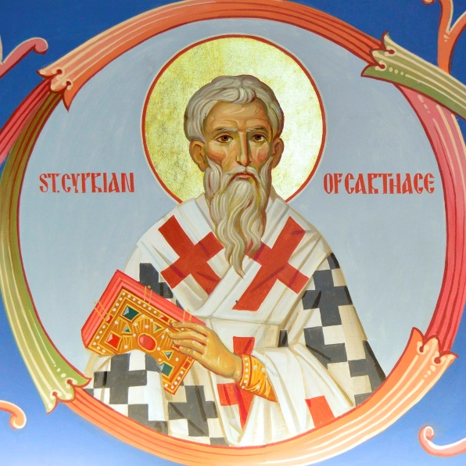
St. Cyprian (c. 200-258) was a courageous leader at a time of terrifying oppression in the early church. Born to wealthy Roman-African parents, he was a lawyer and teacher of rhetoric before converting in middle age. He quickly rose through the ordained ranks to become Bishop of Carthage (near modern-day Tunis) in North Africa, eventually shepherding a scattered and desperate flock during the Decian persecutions. Because of these and other attacks against Christians, a crisis developed concerning people who had succumbed to Roman torture and sacrificed to pagan gods and now wanted to be received back (referred to as the “lapsed”). Taking a moderate stand, Cyprian wrote his renowned treatises On the Fallen (De Lapsis) and On the Unity of the Catholic [meaning universal] Church. He also bore heroic witness to his faith during a plague-induced famine, personally tending to the sick, burying the abandoned dead, and prompting wealthy locals to help the poor. He was eventually martyred. In his important Treatise on the Lord's Prayer Cyprian writes “My dear friends, in these few words there is great spiritual strength, for this summary of divine teaching contains all of our prayers and petitions.” Reflection: It was once (and continues to be in some places in the world) dangerous to freely express one’s Christian beliefs. How far are you willing to go to defend your faith in Jesus Christ? Department of Christian Education
Diocese of the Armenian Church of America (Eastern)/elisea@armeniandiocese.org

