Scripture and Feast Day Notes
Sunday, December 1, 2019

From Today’s Readings
Luke 13:1-9 Jesus refers to two disasters, one in which Pilate had a group of Galileans killed as they were making sacrifices, and another, a construction accident. He asserts that those who died were no more sinful than anyone else (countering a belief that suffering was often visited upon those who deserved it). He urges all to repent and live a good life. Discuss/reflect: The parable of a fig tree not yet bearing fruit (vv 6-9) suggests that there might be some time to straighten ourselves out, but not much! The best time to repent and live godly lives is now. If you had a year like the fig tree to turn your life around, what would you do?
1 Thessalonians 4:1-11 St. Paul exhorts us to live in a way that will “please God,” urging believers to treat their bodies as holy, thereby honoring themselves and others. He counsels them to live quiet lives and be productively busy, relying on their work to sustain them. Discuss/reflect: Paul asks us to love “more and more” (v. 10b). How would that translate to your life? To your relationships?
Isaiah 36:22-37:11 Assyria continues to demand Jerusalem’s surrender. Both King Hezekiah and Isaiah demonstrate their trust in the one true and beloved God over the Assyrian threat. Discuss/reflect: What threats do you think challenge your faith today? Do you trust in God to help you meet these challenges? If not, why not?

Saturday, December 7 is the Feast of St. Nicholas of Myra
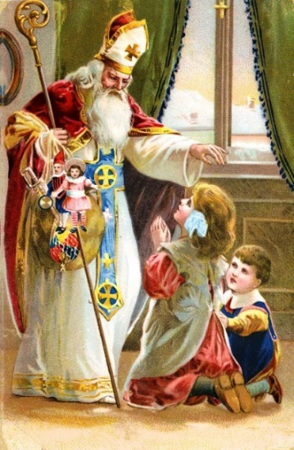
St. Nicholas, Bishop of Myra (c 270-342), was said to have been imprisoned for his faith during the persecution of Christians under Emperor Diocletian and present at the Council at Nicaea in 325. But his name is most associated with Christmas and with the boundless love he had for those in need, a love that inspired miracles.
According to tradition, when Bishop Nicholas’ wealthy parents died, he sold all that he had and distributed the money to the poor. He then devoted himself to helping orphans, widows, and prisoners. One well-known legend of his charity concerned the bags of gold he secretly gifted to three very poor girls whose father was about to turn them out of the house. This led to the practice of children be given presents at Christmas in his name which itself evolved from St. Nicholas to Santa Claus. The modern day image of Santa also draws from the story of the pagan god Thor who was associated with winter and the Yule log and rode on a chariot drawn by goats named Cracker and Gnasher. Reflection: Santa Claus appears each year to be seen and heard for a short time; St. Nicholas is part of the communion of saints, surrounding us always with prayer and example. Which gets more of your attention at Christmastime?

Department of Christian Education
Diocese of the Armenian Church (Eastern
)elisea@armeniandiocese.org

