Scripture and Feast Day Notes
Sunday, November 17, 2019

From Today’s Readings

Luke 9:44-50 Although they have just heard their beloved Master predict His betrayal, the disciples blithely begin to argue about who among them would be the greatest. Jesus derails their misguided debate by bringing a child to his side and challenging them to welcome the child and others who are helpless and “least” in the world’s eyes. A true disciple understands that these are the greatest in the kingdom and recognizes Jesus in them. The theme of welcoming extends to the man driving out demons (vv 49-50) for whom he also asks a generosity of heart. Discuss/reflect: In what ways do you reach out to the “least”?

Philippians 1:1-11 St. Paul joyfully remembers the Philippians as deeply faithful and thinks of them as his fellow travelers, sharing in God’s grace. He affirms that because of their faith and missionary zeal (“your partnership in the gospel from the first”), God will continue to work in their lives and will bring their mission to “completion” at the end of time. Discuss/reflect: This is one of the most joyful of St. Paul’s letters, as he cheerleads his beloved church in Philippi. For whom can you serve as spiritual cheerleader?

Isaiah 25: 9-26:7 These verses begin with an oracle against Moab, a neighbor of Judea, and end, in Chapter 26, with a beautiful psalm-like prayer of trust in God. Discuss/reflect: What do each of these images: ramparts (v.1), gates (v.2), steadfast mind (v.3), the Rock (v.4), level paths (7) contribute to a picture of faith?

November 21 is the Feast of the Presentation of St. Mary to the Temple
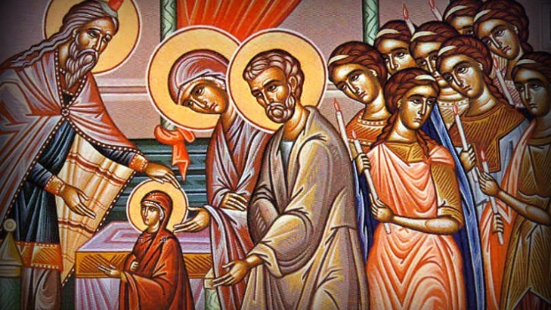
The early life of St. Mary does not appear in the Gospels. According to Holy Tradition, however, we know that her parents Sts. Joachim and Anna had prayed that they might have a child and made a solemn promise that if God were to bless them with one, they would dedicate him or her to His service. A daughter, Mary, was born to them, and they did not forget their vow. When Mary was three years old, her parents took her to the Temple where she was dedicated and where she stayed in the care of devoted women until she was betrothed at about the age of fourteen. This Feast Day is “immoveable,” meaning that it is celebrated on the fixed date of November 21 regardless of the day of the week on which it might fall.

Department of Christian Education
Diocese of the Armenian Church (Eastern)
elisea@armeniandiocese.org

