Scripture and Feast Day Notes
Sunday, January 5, 2020

From Today’s Readings
Matthew 2:1-12 The story of the visit of the magi needs no summary, it is so well-known and beloved. And yet some of the legendary details - that these are kings, wise men, three (even named Caspar, Balthasar, and Melchior in later Christian traditions), take away from the core facts that while purportedly learned, especially in astronomy and astrology, they were first and foremost humble men of profound faith, listening to their hearts and following God’s direction, worshiping the baby, confident He was God incarnate. The wise and powerful are notoriously resistant to God’s direction – we are reminded repeatedly of this in Scripture - so perhaps our sentimental adherence to the details of this story may not be the best focus. Notice in this account how Jesus inspired both hostility and worship – a foreshadowing of what was to come. Discuss/reflect: Prayerfully read the story of the magi’s visit. How would you rate your confidence in Jesus? Strong enough to seek and follow Him as they did?
Titus 2: 11-15 The writer reminds us that God’s grace brought salvation to all people through Jesus Christ; therefore all should live godly lives in hopeful expectation of His return. Discuss/reflect: Think of specific ways in your life that you can say “no! to ungodliness and worldly passions.” (v.11)

Monday, January 6 is Armenian Christmas!

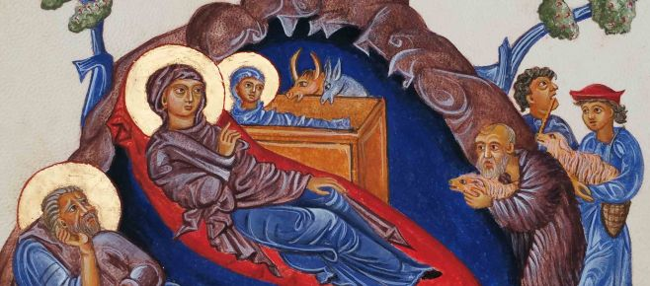
While much of the Christian world celebrates the birth of Christ on December 25, the Armenian Church celebrates His birth and baptism on the feast of Asdvadzahayd-nootyoon on January 6. Surprisingly to us today, the beautiful accounts of Jesus’ birth – the stuff of Christmas pageants through the ages - was of less interest to the Early Church. The nativity of Christ was not viewed as the “birthday” of Jesus Christ the same way we tend to view birthdays; rather, the reverent emphasis was on Christ’s death and resurrection (beautifully demonstrated in Armenian miniatures where the baby Jesus is always shown with a cross embedded in His halo). Yet looking back at His birth from the perspective of His death, the nativity takes on deeper meaning, not as the birthday of a person, but as the coming of salvation into this world in Jesus Christ. Good News to you and us…
Christ was born and revealed! Blessed is the revelation of Christ!
Department of Christian Education
Diocese of the Armenian Church (Eastern)
elisea@armeniandiocese.org

