Scripture and Feast Day Notes
Sunday, October 4, 2020
From Today’s Readings
Mark 11:27-33 This confrontation occurs after Jesus’ triumphant arrival in Jerusalem and His driving out the moneylenders from the Temple. Already angered by these events, the chief priests question His authority. Discuss/reflect: When we question Jesus’ authority in our lives, how are we any different from His enemies in 1st century Palestine? How does your life reflect that you truly believe He governs your life?
2 Corinthians 13:5-13 St. Paul reminds the believers of Corinth to examine their lives – are they truly living their faith? “Do you not realize that Jesus Christ is in you?”(v. 5) Even in his own weakness, he prays for their strength. “Put things in order…agree with one another,” he tenderly advises, and “the God of love and peace will be with you.”(v. 11) Discuss/reflect: In verse 12, believers are asked to greet one another with a holy kiss. This same bidding appears in a few of St. Paul’s epistles and is the very same used by the deacon to invite us to the Kiss of Peace during Badarak. Think now and remember later when you engage in that beautiful ritual in church: is this greeting a genuine sharing of my love and faith?
Isaiah 17:7-14 Isaiah prophecies against Syria and Israel, whose people have forgotten God. “You have not remembered your Rock, your fortress.”(v.10) As a result, no human effort can be fruitful. Discuss/reflect: God is often depicted as a fortress in the Old Testament. When you hear that word, what images come to mind? Is God your fortress?

Saturday, October 10, is the Feast of the Holy Translators
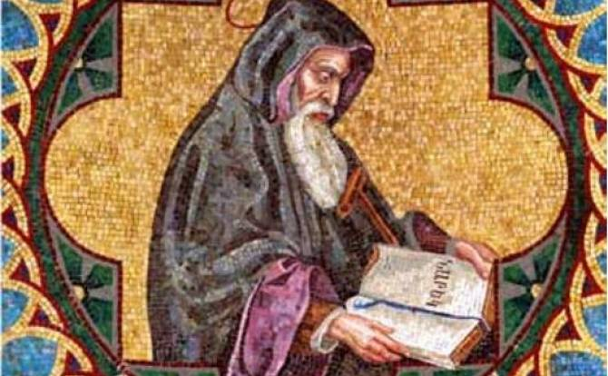
Holy Translators, Mesrob, Yeghishe, Moses the Poet, David the Philosopher, Gregory of Narek, Nersess the Grace-filled… These well-known saints are remembered on other days of the church calendar year, but the Armenian Church remembers them here specifically as “translators,” those who enlighten others about our faith through prayers, hymns, poetry, philosophy and even history. Translation goes beyond rendering one language into another. It is the sharing of the experience of Christ with His people, to those who will also become translators for His Church.
St. Gregory of Narek (c 945-1003) was a beloved teacher, churchman and prolific writer. Born in Narek (near Lake Van) he entered the monastery there and wrote Bible commentaries, history and deeply affecting prayers. His renowned collection Speaking with God from the Depths of My Heart was so treasured that it was thought to have healing powers. This Sunday begin class (or the day) with one of his prayers (from Prayer 82): “Erase my transgressions, compassionate One; extend your hand of deliverance and I will instantly be made perfect. Providential Lord, revive me, made in your image and brought to life by your breath.”
Reflection: How might always recalling you are made in God’s image change your thinking and behavior? Be specific! Department of Christian Education/Diocese of the Armenian Church of America (Eastern
elisea@armeniandiocese.org

