Scripture and Feast Day Notes
Sunday, September 13, 2020
From Today’s Readings
John 3:13-21 Jesus tells the Pharisee Nicodemus (who has sought Him to learn more) that He came into the world to save it and not to condemn it and that all who believe in Him will have eternal life. Light has come into the world and people can now choose truth over darkness. Discuss/reflect: Memorable verse (John 3:16) “For God so loved the world that He gave His one and only Son, that whoever believes in Him shall not perish but have eternal life.” How would this belief change your life even now?
Galatians 6:14-18 St. Paul declares that the cross is the only source of pride and joy to him and that in Christ the world has been “crucified to me.” His past, his “tribe,” his earthly affiliations mean nothing – he has been made new in Christ (15). Discuss/reflect: St. Paul describes bearing the marks of Jesus on his body (17). Such an intimate and concrete image! How does this image help you better understand Jesus’ effect on Paul? How would you describe His effect on you?
Isaiah 49:13-23 A refrain of joyous comfort from God who declares that His people will never be forgotten. ‘Lift up your eyes and look around you,’ (18) the Lord declares, ‘even in your forsakenness know that I will lift up my victorious banner.’ (19-22) The analogy of a mother’s love in verse 15 is another example of God’s tenderness expressed in female imagery. Discuss/reflect: These distressing times have surely absorbed us all in our everyday problems. Each night before you sleep, “lift up your eyes and look around” and take concrete notice of God’s glorious presence in your life and in the world.

Today is the Feast of the Exaltation of the Holy Cross
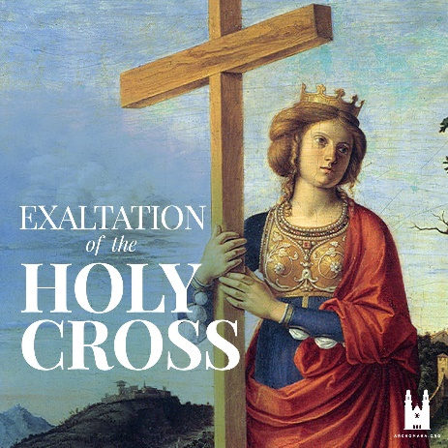
This is one of the five major feasts (daghavars) of the Armenian Church and is celebrated on the Sunday nearest September 14. On that day, there is a procession and an antasdan service or Blessing of the World (four corners).
In early times, the most important church in Jerusalem was named the Church of the Holy Cross. It had been built over the place where Jesus was crucified. Every year, the bishop would take out a relic of the cross and elevate it over his head for the people to honor and venerate. This ceremony is the origin of the Feast of the Exaltation of the Cross.
Traditionally, we associate another story with this Feast Day. In the 7th century, the Persians captured the cross of our Lord after devastating the city of Jerusalem. Emperor Heracles fought a battle against them – in which the Armenian army participated – and liberated the cross. Upon his return, he exalted it in Christian lands, including Armenia -- through which the victorious army carried it back to Jerusalem.
Activity: If you have a wall cross in your home, adorn it with fresh basil leaves -- a fragrant herb that is a symbol of royalty and love – just as the cross has been adorned in church today. Let it serve as a prayerful reminder of the Lord’s sacrifice which has made your life transcendent now and for all eternity.

Department of Christian Education
Diocese of the Armenian Church of America (Eastern) /elisea@armeniandiocese.org

