Scripture and Feast Day Notes
Sunday, October 18, 2020
From Today’s Readings
Luke 4:14-23 “Filled with the Holy Spirit” after His baptism, Jesus is led into the wilderness by that same Spirit for a triumphant encounter with the devil. He then returns to His hometown “in the power of the Spirit” to preach in the synagogue, quoting from the prophet Isaiah (61:1) that “the Spirit of the Lord is upon me.” (18). Discuss/reflect: The Holy Spirit is an important presence in Luke’s Gospel. Look up all the places in this Gospel where the Holy Spirit is mentioned. Pray over these words, asking for the Spirit’s wisdom and guidance.
Galatians 4:3-18 St. Paul reminds the Galatians that in Christ they are God’s sons and daughters and therefore not slaves to pagan philosophies. He calls on their friendship and open-hearted spirit to turn from wrong influences. Discuss/reflect: In a renowned verse (6), St. Paul says that now that we are His children, God drives the Spirit (again, the Spirit!) of the Son into our hearts and the Spirit cries out “Abba! Father!” This not a gentle image, more like an invasion. Have you felt the Spirit’s unmistakable presence? What might you do to discover it?
Isaiah 20:2-21:6 The Judeans were looking to Egypt and Cush with hope, awed by their might; yet Isaiah shares a vision of their shameful fall. Discuss/reflect: What lesson is offered in Isaiah’s vision of once-powerful empires fallen and shamed by God? What metaphorical “empires” do you look to in your life for comfort and strength rather than to God?

Saturday, October 24: Twelve Church Fathers -- St. Athanasius
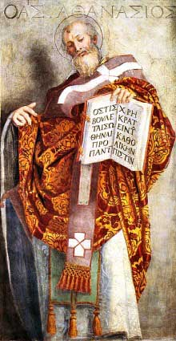
Born (c.298) in the cosmopolitan city of Alexandria where he spent most of his life, Athanasius was present at the Council of Nicaea in 325 as the Bishop of Alexandria’s attendant. He was then a young deacon and spoke eloquently against the heretic Arius who denied Christ’s eternal divinity. He was later appointed the Bishop’s successor and despite repeated exiles due to persecution and politics, he became a prolific apologist of the Christian faith and a revered church leader. Of note: He wrote the popular and influential Life of St. Antony and his Easter Letter of 367 is the earliest reference to the canon of New Testament books as we have them today. Athanasius’ masterpiece, On the Incarnation, is a celebrated defense of the full humanity and full divinity of Jesus. It likens fallen humanity to a painting that had been defaced from its original splendor by “external stains” (sin), requiring a new person – Jesus Christ -- to sit again for the master painter. In orthodoxy, the beautiful concept of theosis is this, as St. Athanasius said: “Jesus became what we are that he might make us what he is.” Reflection: If your character, habits, and heart were a painting, where do you think you need God’s loving restoration?

Department of Christian Education/ Diocese of the Armenian Church of America (Eastern)/elisea@armeniandiocese.org

