Scripture and Feast Day Notes
Sunday, December 13, 2020

From Today’s Readings
Luke 17:1-10 Jesus continues to teach about true discipleship. Here he tells his disciples:
1) while sin is bound to happen, it would be very wrong to be the cause of it in someone else, 2) forgive those who have hurt you and have asked for forgiveness (no matter how often!), 3) even as you ask for more faith, know that a faith as small as a mustard seed still can work miracles and 4) don’t be proud of your faithful acts, as you are simply following me and doing what you should. Discuss/reflect: Jesus offers a “Basic Discipleship 101” here with four foundational points. Which one speaks to you?
Hebrews 1:1-14 The epistle writer enumerates the qualities of Jesus who is greater than the prophets and the angels. He is the Son of God; he is the radiance of the Father’s glory even while sharing in his same nature. Having cleansed us of our sins, He sits at the Father’s right hand. With Him, God created the universe. Discuss/reflect: To counter heretical notions of his time, the writer of Hebrews elaborates on how Jesus is greater than the angels. How would you describe Jesus to yourself? To others?
Isaiah 38:1-8 King Hezekiah, ill and at the point of death, prays for healing. God restores the King’s health and pledges protection to Jerusalem. Discuss/reflect: Yearning to be healed, Hezekiah prays tearfully that he had walked with the Lord in faith, whole-heartedly, doing what was “good in your sight”. (v 3). Would you be able to make that same declaration? Be specific.
December 19 is the Feast of St. Abkar, First Christian King
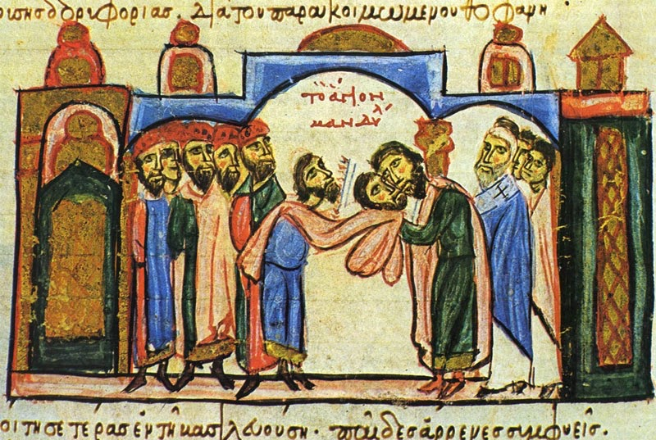
The story of King Abgar is found in early histories including those of Eusebius of Caserea and our own Movses Khorenatzi. Then a prince of Edessa, Abkar was purported to have given the magi a gift to present to the baby Jesus. Decades later, he had become gravely ill. Hearing of Jesus’ miraculous healings and unable to travel to Jerusalem, he wrote a letter asking Him to come to Edessa, that he might worship Him and be healed. Jesus wrote back saying that while He could not come, He would send the apostle Thaddeus to heal him in His name. (One of the legends is that the messenger bearing the letter was also a painter and had created a portrait of Jesus which he brought with him. This portrait is often included in images of Abkar.) The king was healed and baptized a Christian along with several of his subjects. At every Badarak, he is remembered by name with other “saintly and pious kings and God-loving princes.” Reflection: Pray as if you are writing a letter to Jesus. What would you ask him to heal?
Department of Christian Education/Diocese of the Armenian Church of America (Eastern)/elisea@armeniandiocese.org

