Scripture and Feast Day Notes
Sunday, January 10, 2021

From Today’s Readings
John 1:18-28 When Jewish leaders in Jerusalem sent priests and Levites to question John the Baptist and investigate his activities, John assured them that he was not the Messiah. He was, rather (quoting the prophet Isaiah), “a voice in the wilderness, making straight the way for the Lord.” (v23) and unworthy of even untying the sandals of the One who would be coming soon. Discuss/reflect: John is asked to answer this (v 22): “Who are you? What do you say about yourself?” How would you answer this question if it were exclusively about your faith?
Luke 1:39-56 Shortly after learning that she will be the mother of Jesus, Mary hurries through the hills of Judea to her cousin Elizabeth, now pregnant with John the Baptist. Elizabeth exclaims in knowing praise: “Blessed are you among women and blessed is the fruit of your womb!” Mary herself glorifies God in a prayerful song of joy and praise. Discuss/reflect: Glorify the Lord with words of praise and hope, specific to where you are in your life.
Hebrews 12: 18-27 The writer compares the fearsome dread associated with Mt. Zion, symbol of the law and the old covenant, with the jubilant assemblies of angels in a heavenly Jerusalem and a new covenant mediated by Christ. Fear and vengeance are replaced by joy and forgiveness; an “unshakable” kingdom is promised to those who are faithful. Discuss/reflect: “Take care to listen to the One who speaks to us from heaven.” (v.25) Are you listening? How do what you think, say and do reflect what you’re hearing?

January 13: Feast of the Naming of Jesus
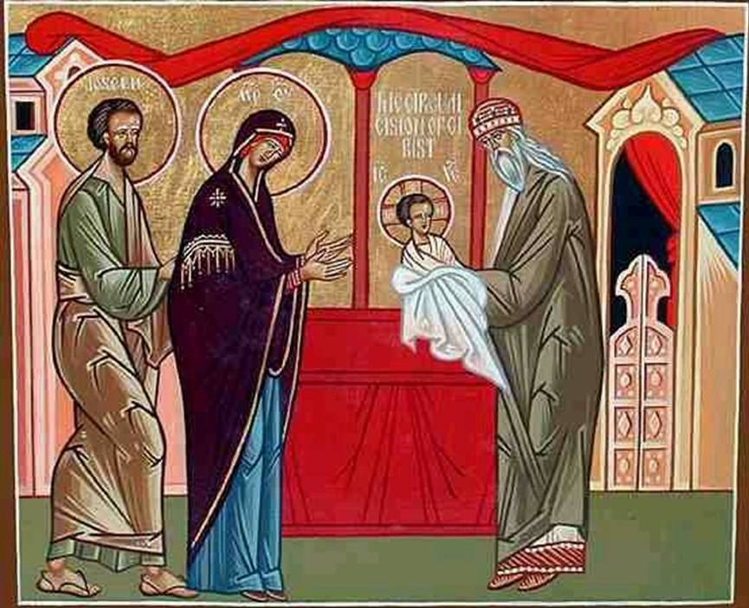
In Matthew 1:21 and in Luke 1:31 we read about two extraordinary messages delivered by the angel Gabriel. In Matthew, the angel appears to Joseph in a dream saying that the name of the child Mary would bear was to be Jesus. In the Gospel of Luke, the angel tells Mary that her child would be called Jesus. The name Jesus is related to both the Hebrew and Aramaic, meaning “he will save” or “savior.” His official naming (Luke 2:21) took place on the eighth day on the occasion of the circumcision, in keeping with Hebraic law, and is commemorated by the Church on January 13. (Jesus was not named Jesus Christ at the time of his birth. The word Christ is a title and means “the anointed one” or “the Messiah.”) We celebrate the naming because it heralds Jesus’ very purpose and mission as Savior and Redeemer. Reflection: List all the names of Jesus in Scripture (i.e. John 6:35-bread of life; Isaiah 9:6 prince of peace, etc.). Use them in a prayer of praise.

Department of Christian Education/Diocese of the Armenian Church of America (Eastern)/elisea@armeniandiocese.org

