Scripture and Feast Day Notes
Sunday, January 31, 2021

From Today’s Readings
John 6:22-38 Having witnessed the miracle of Jesus feeding thousands with just a few loaves and fish, the people eagerly seek him, asking: ‘What other miraculous sign will you give us? Will it be like the manna God sent down to our ancestors in the wilderness?’ Jesus answers that he offers more than physical sustenance. He is the true bread from heaven: “I am the bread of life; he who comes to me will never go hungry.” (v.35) Discuss/reflect: Bread is a symbol for the physical food we need to live. What kind of hunger do you think Jesus is talking about when he says we will “never be hungry again?” What worldly hungers distract you from the nourishment only Jesus can provide?

2 Tim 3:1-12 St. Paul warns Timothy of false teachers who might appear godly and yet their behavior will reveal their character (v. 8: Jannes and Jambres were Egyptian court magicians at the time of Moses, false teachers themselves). He also declares that following Christ is not easy! (v.12) For many, it will be easier to be selfish, greedy, unforgiving, unloving, ungrateful and vain pleasure-seekers (vv 2-4). Discuss/reflect: Do the disagreeable qualities listed in vv 2-4 figure in today’s world? Are there times you display a “form of godliness” (v 5) without the inner heart for God?

Is 63:7-18 Almost Psalm-like in structure, these verses recall God’s saving actions in the past (such as the Exodus), acknowledge the sins of Israel, and end with a plea for mercy. Discuss/reflect: In verse 7, the prophet sings “of the kindnesses of the Lord.” Make such a list from what you observe in the world, in others, and in your own life.

Friday, February 5: St. Sahag Bartev
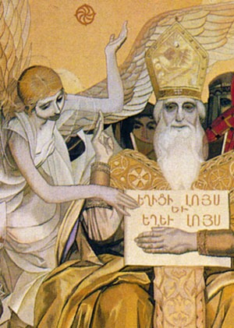
As the son of St. Nersess the Great and the grandfather of St. Vartan Mamigonian, St. Sahag was part of a long and illustrious story. He was elevated to Catholicos (387) during the very difficult period of Armenia’s partition between Persia and Byzantium and witnessed its sad deterioration and the rise and fall of numerous kings. Aside from his strong leadership in those earlier dark years, he presided over the new burst of creativity in the 5th century “Golden Age,” during which time he worked with St Mesrob to create an Armenian alphabet and guided the work of translating the Bible. He established schools, compiled the first books of ritual, wrote hymns and prayers and, as a result of his prodigious work, is acknowledged to be the founder of Armenian ecclesiastical and national literature.
` Department of Christian Education
Diocese of the Armenian Church (Eastern)
elisea@armeniandiocese.org

