Scripture and Feast Day Notes
Sunday, August 1, 2021

From Today’s Readings
John 3:13-21 Jesus is teaching the Pharisee Nicodemus and has just given his famous explanation of being born again. He now declares the equally renowned words: “For God so loved the world, he gave his only begotten Son.” (3:16) Through the Son the world is saved, and through his light and truth, people are redeemed. Sadly, many prefer the darkness (19-20). Discuss/reflect: Imagine Jesus before you, exuding a warm, inviting light, a light that leaves nothing unexposed, nothing in shadow, shining so brightly on you that you have to shade your eyes. What about such a light might make you recoil? What might you need to do to draw closer and bask in this life-giving light?
1 Timothy 4:12-5:10 Placed in charge of the church founded in Ephesus by St. Paul, Timothy is encouraged to be confident in his teaching and leadership, even though he is a young man. He is advised to be an example in every way and to treat others with love and respect, always helping those in need. Many verses are devoted to the care of widows, as these women were extremely vulnerable in a time when men were the legal and familial protectors of their families. Discuss/reflect: How might paying attention to your own faith and witness help others (4:16)?
Isaiah 58:13-59:7 These two chapters address the attitudes of the Jewish community upon their return from exile. Following in a long tradition of prophetic criticism, the writer exhorts people to honor God’s holy day with joy and hearts of faith. Social justice is essential to holiness and honoring God; pious practices are meaningless if they are engaged in by a sinful, unjust society. Discuss/reflect: Is there a way you can change your Sunday habits that might please God more and lead to deeper happiness for you (58:13-14)?

Monday.August 2: St. Vahan of Goghtn (703-737 AD)
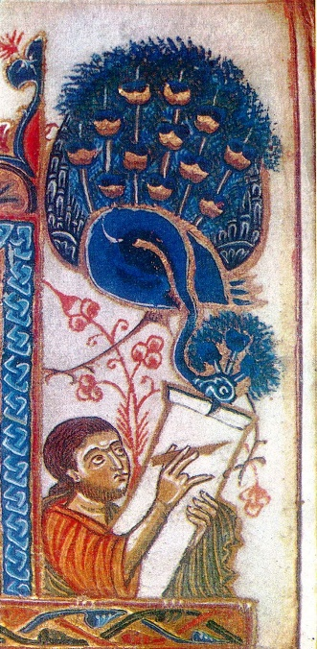
The story of St. Vahan of Goghtn is one of the most poignant among Armenian saints. He was born in the eighth century of a princely family in the Goghtn region of the province of Siunik. After persecution of the Armenians by the Arabs in 707 (during which Vahan’s father, Prince Khosrov, was killed), four-year-old Vahan was taken to Damascus where he was raised in the royal court as a Muslim. He was eventually appointed chancellor to the Emir. Some years later, he was allowed to go back to Armenia with the promise that he would eventually return. Vahan converted to Christianity, married an Armenian princess, and lived a peaceful life for about a decade. With a change of Arab rule, Vahan was sought after, so he left his home and family to escape recapture. While in exile, he became a monk. In 736, Vahan went to the new Arab Emir in despair. The Emir offered him a high position, authority, and wealth, but Vahan refused, preferring his faith in Christ to personal comfort and glory. He was martyred in 737 A.D. His last words were a bold declaration: “I choose death for the sake of Christ rather than earthly life.” Reflection: Would you be
prepared to make such a choice? Department of Christian Education, elisea@armeniandiocese.org

