Scripture and Feast Day Notes
Sunday, July 11, 2021

From Today’s Readings
Wisdom 7:25-8:4 Solomon extols the virtues of wisdom, having sought her from his youth: she is a powerful source of renewal, prevails against evil, and draws us to friendship with God since “God loves nothing so much as the person who loves wisdom.” (v. 28) Discuss/reflect: In 1 Kings 3: 1-15, God asks Solomon what he wants most. Rather than long life or wealth, he asks for wisdom, which in Hebrew is literally “a listening heart.” How might such a heart help you?
Zechariah 14: 16-21 Declaring that a day is coming when the Lord will be king over the whole earth, the prophet foresees that all -- even former enemies of the faith -- will be called to Jerusalem on the Feast of the Tabernacles to celebrate and worship him as the Lord Almighty. Discuss/reflect: “Holy to the Lord” will be inscribed on the horses’ bells and on cooking pots (v.20) on that day. What parts of your life do you feel are inscribed to the Lord?
1 John 1:1-7 John proclaims the truth of Jesus Christ based on all he has seen, heard, and touched so that others “may have fellowship with us” (v. 3) and in turn with God. God is light and walking in that light means living by the truth and loving God and one another. Discuss/reflect: In what ways have you, like John, “seen,” “heard,” and “touched” Jesus?
Matthew 16:13-17:13 This rich account, worthy of a long summation, begins with the important conversation at Caesarea Philippi when Jesus asks “Who do people say I am?” After hearing the answers (John the Baptist, a prophet), he asks “and who do you say I am?” To which Peter famously replies “You are the Christ, the Son of God.” In the next account, Jesus predicts his death and counsels that anyone who follows him must take up his cross as well for “those who want to save their life will lose it.” Finally, we read the account of Jesus’ transfiguration (see below). Discuss/reflect: Imagine Jesus sitting across from you, taking your hands in his, and asking you: Who do you say I am? How would you answer?

Today is the Feast of the Transfiguration
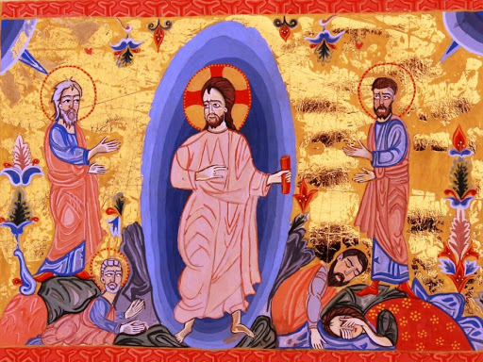
The Transfiguration, one of the five major feasts of the Armenian Church, marks the extraordinary occasion Jesus took his three closest disciples, Peter, James, and John, up to Mt. Tabor where he was “transfigured,” appearing radiant. Moses and Elijah appeared at his side, symbols of the Law and Prophecy which Jesus had come to fulfill. A voice from heaven was heard saying: “This is my beloved Son.”
Some customs of an ancient Armenian pagan festival for the goddess Asdghig are still associated with this feast, such as decorating the church with roses (and
therefore the Feast’s name Vartavar; it is more formally called Aylagerbootyoon or Baydzaragerbootyoon) and spraying one another with water. Reflection: Only in Matthew, do we learn the disciples’ reaction to this miracle: fear and awe, calmed by Jesus’ touch. (17:6-7)Think of a time when you were afraid, anxious, or confused. Were you aware of Jesus’ presence? Next time you feel this way, prayerfully dwell on the Lord’s radiant transfiguration.
Dept of Christian Education/Diocese of the Armenian Church of America (Eastern)/elisea@armeniandiocese.org

