Scripture and Feast Day Notes
Sunday, March 6, 2022 Sunday of the Expulsion
From Today’s Readings 2018
Matthew 5: 17-48 Jesus calls the world to a level of righteousness. Sin starts in the heart and Jesus itemizes these sins with their prescribed resolution: Anger against one’s fellow: forgive and reconcile. Lust is a state of mind: do your utmost to prevent this (gouge out your eye if need be!). Breaking marital bonds is wrong (remember Jesus’ harsh language here is akin to his suggestion we gouge out our eye to avoid lust - an overstatement to make a point). Oaths are sacred: keep them. Do more, not less, for anyone needing your help. Lovingly pray for your enemies. Discuss/reflect: These remain as head-spinningly demanding as they must have been to Jesus’ listeners. Read these verses prayerfully. Decide which attitude you might work on as a Lenten discipline.
Romans 12:1-13:10 St. Paul urges the Romans to “be transformed” according to God’s “good, pleasing, and perfect will.” (12:2) He advises the humble use of our God-given spiritual gifts. That we be devoted to one another, sharing with those in need. That we live in peace, overcoming evil with good. That love is the ultimate all-encompassing ‘law’ (13:10). Discuss/reflect: For the days of Lent still ahead, use 12:12 as a daily prayer: “Today, Lord, help me be joyful in hope, patient in affliction, and faithful in prayer.”
Isaiah 33: 2-22 In the shadow of Assyria’s invasion, God’s people turn once again to Him for support and salvation. They have grown to better know who He is and what He can do, even through their times of apostasy. The righteous are promised divine intervention; evil will be toppled. The holy city will prevail and there the Lord will preside as the “Mighty One.” Discuss/reflect: We are promised one day to “see the King in His beauty.” (17) In the biblical world, mirrors were made of polished metal; images were distorted. St. Paul also promised a clear view someday (“now we see in a mirror dimly, then we will see face-to-face”-1 Cor 13:12)
Close your eyes and imagine that moment. What do you see?
Today is the Sunday of the Expulsion
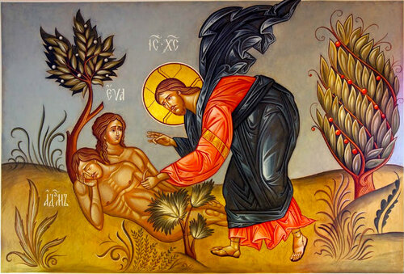
Expulsion Sunday reminds us of that original exile from God’s presence: Adam and Eve driven our of Paradise for eating from the tree that had been forbidden to them.
The notion that they were wiser than God in deciding to eat the fruit of the “knowledge of good and evil” is at the heart of every sinful thought or action to this day. And even now, when we do something we’re not proud of, facing God is indeed as difficult as it was for Adam and Eve who tried to hide from Him as He walked “in the Garden in the cool of the day.” (Genesis 3:8) Thankfully, in God’s loving mercy, this is an exile He will not let us endure forever. Great Lent is a unique opportunity to ponder God’s absence even as we seek Him in 40 days of prayer and reflection. Reflection: Read Genesis 3. Why would God allow Adam and Eve to fail when tempted? What does this say about God? About what He wants from us?
Dept of Christian Ed/Diocese of the Armenian Church of America(Eastern), elisea@armeniandiocese.org.

